ERD Assignment 2

Please double-click “Name” above and enter your name.

Please fill in your answers in the spaces provided and submit this file on Blackboard. Please submit it as a Word document only – do not convert to PDF.

* When asked to draw ERDs, please draw them in Oracle Data Modeler and then paste the image file into this document at the appropriate place.
* For answers that you type in, please use the Arial Black font so that I can locate your answers easily.

1. Based on the diagram below, answer the questions that follow the diagram. **When asked to count attributes, you should count all attributes – including implicit foreign key attributes**.   
   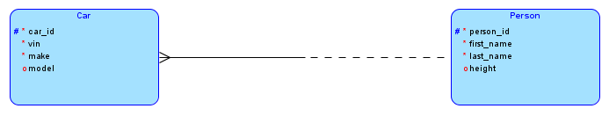

* Primary key for Car: **car_id**
* Primary key for Person: **person_id**
* Number of attributes for Car: **5 (4 visible ones plus the implicit foreign key person_id)**
* Number of attributes for Person: **4**
* Number of optional attributes for Person: **1 -- height**
* Number of required attributes for Car: **4 – three visible ones plus the foreign key person_id. Since Car has obligatory participation (every car must be owned by one person), we need to indicate the person to whom a car belongs as the person_id. Hence this attribute becomes a required attribute. If on the other hand, Car did not have obligatory participation, then the person_id foreign key would have been an optional attribute.**
* Degree of the relationship: **1:n**
* Entity type(s) that has (have) obligatory participation: **Car – its side of the relationship line is solid.**

1. There are many books and persons. Each book is authored by one or more persons and each person might be the author of zero or more books. A designer created the following ERD first, with the m:n relationship and then refined it with the associative entity Book-Author as shown in the next diagram (we have not shown the three entity types in one line, but the meaning remains unchanged). Use the second diagram below to answer the questions that follow it.

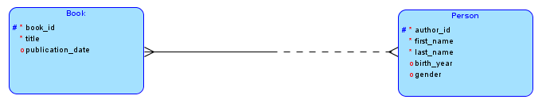

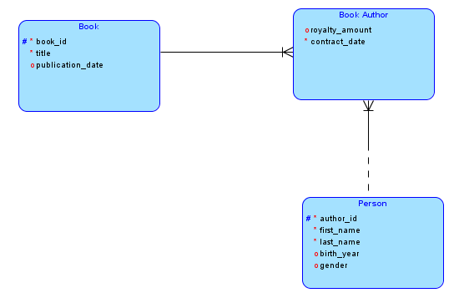

* Number of attributes for Book-Author: **4 – two visible ones, plus the two foreign key attributes book_id and person_id.**
* Number of required attributes for Book_Author: **3 – contract_date plus the primary key consisting of book_id and person_id**
* Primary key for Book-Author: **book_id + person_id**

Draw ER Diagrams for questions 3 to 6. Use proper cardinality notation showing both degree and participation. Use Oracle Data Modeler to draw the ERDs and export the diagrams as image files and paste in this Word document..

1. Every employee is assigned an office. An office might be assigned to one employee or might be empty. **1:1 relationship, so no crow-feet. Employee has obligatory participation – hence solid half-line. Office has non-obligatory participation – hence dashed half-line.**  
     
   
2. Each car company might be the manufacturer of many models of cars or the company could be new and might not have any models yet. Every model of car is made by exactly one company.   
     
   **1:n relationship. Car company non-obligatory. Model obligatory.**  
   
3. An apartment rental company owns many apartment complexes across the country. Each complex has a unique id, complex name, year it was built in and street, city and zip. Each building has a building number, the date it was last painted and the style of the building. The building number is unique within a complex, but not across complexes. To uniquely identify a building, we need the id of the complex and the building number. (I did not mention these originally. I hope you made suitable assumptions: Each apartment complex has one or many buildings and each building belongs to exactly one apartment complex. )  **Needs key migration notation for Building, since its key is also made up of the primary key of the apartment complex.**  
     
   
4. The ERD below shows that a supplier might be the supplier of one or many parts, and that zero or several suppliers might supply a part. For example, supplier 1 supplied 200 units of part A on Jan 5, 2011 and supplier 2 supplied 300 units of part B on Feb 1, 2012. Supplier 1 also supplied 150 units of part B and 65 units of part C on March 2011. Part D has not had any shipments so far. For now, assume that we need to store information only about the latest shipment that suppliers made of each part that they supplied.  
     
   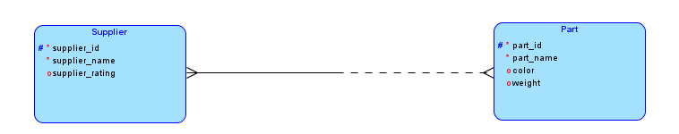

As we discussed in class, whenever we have a m:n relationship, we always convert it into an associative entity. Draw the ERD with the associative entity – you need to show only one non-key attribute for the associative entity.. Use proper cardinality notation and also show the primary key for the associative entity using appropriate notation.  **We have created an associative entity type and called it Shipment. The quantity and the shipment date can both be attributes of the associative entity type. The primary key of Shipment is the combination of supplier_id and product_id.**

**If it is possible that the same supplier might have made many shipments of the same product many times and we need to store them all, then the above primary key will be insufficient and we will have to make the shipment date also part of the primary key and place a # sign next to it.**

